**JavaScript Objects**

JavaScript object is a variable that can store multiple data in key-value pairs.

**Example**

**// student object**

**const student = {**

**firstName: "Jack",**

**rollNo: 32**

**};**

**console.log(student);**

**// Output: { firstName: 'Jack', rollNo: 32 }**

**Here, student is an object that stores the first name and the roll number of students as key-value pairs.**

**The syntax of JavaScript object is:**

const objectName = {

key1: value1,

key2: value2,

...,

keyN: valueN

};

**JavaScript Object Properties**

In JavaScript, the key-value pairs of an object are referred to as properties. For example,

**const person = {**

**name: "John",**

**age: 20,**

**};**

**Here, name: "John" and age: 30 are the properties of the object person.**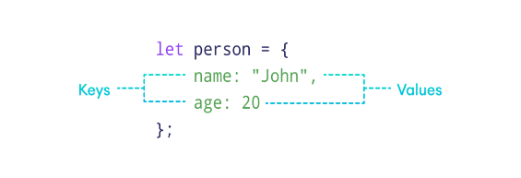

**Access Object Properties**

You can access the value of a property by using its key.

1. **Using Dot Notation**

**const dog = {**

**name: "Rocky",**

**};**

**// access property**

**console.log(dog.name);**

**// Output: Rocky**

1. **Using Bracket Notation**

**const cat = {**

**name: "Luna",**

**};**

**// access property**

**console.log(cat["name"]);**

**// Output: Luna**

**JavaScript Object Operations**

1. **Modify Object Properties**

**We can modify object properties by assigning a new value to an existing key. For example,**

**const person = {**

**name: "Bobby",**

**hobby: "Dancing",**

**};**

**// modify property**

**person.hobby = "Singing";**

**// display the object**

**console.log(person);**

**// Output: { name: 'Bobby', hobby: 'Singing' }**

**2. Add Object Properties**

**const student = {**

**name: "John",**

**age: 20,**

**};**

**// add properties**

**student.rollNo = 14;**

**student.faculty = "Science";**

**// display the object**

**console.log(student);**

**// Output: { name: 'John', age: 20, rollNo: 14, faculty: 'Science' }**

**3. Delete Object Properties**

**const employee = {**

**name: "Tony",**

**position: "Officer",**

**salary: 30000,**

**};**

**// delete object property**

**delete employee.salary**

**// display the object**

**console.log(employee);**

**// Output: { name: 'Tony', position: 'Officer' }**